Synth

Power supply

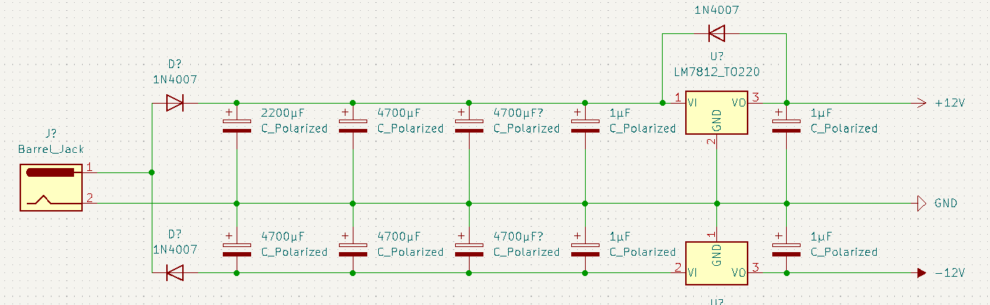

The power supply dual rail with +12V, -12V and GND. This is needed as some electronics components like operational amplifiers need the negative voltage to prevent distortion. The power supply is connected to mains using an AC-AC adapter that supplies 12V AC and can provide 1000 mA.  
The AC is needed to efficiently create a dual rail power supply.

The power supply plugs in using a female barrel jack input which connects to the AC-AC adapter. One terminal is designated as ground and the other is used for the dual rails.

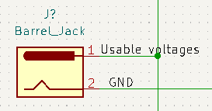

The terminal that is used for the dual rails is then isolated into the negative and positive parts of the AC signal using rectifying diodes, they can handle 1A each. The positive values are passed using a normal diode setup, the negative ones are passed using a flipped one so it passes the negative ones (Don’t try to understand why, just go with it):

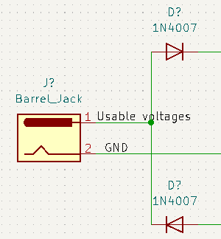

The signals look like this for the positive signal and the negative you can imagine as the gaps in between just going down.

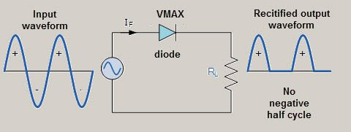



The result of this isolation is not exactly usable voltage, it has high peaks and long gaps. You can get the peak voltage using this: 12V AC * sqrt(2) = 16.97V (Approx. 17V). That is not 12V and is not usable. We have to bring in some capacitors to smooth everything out by taking in power when the circuit has power and outputting it when it does not. If we put in any capacitor of sufficient size to make up for the gap between the power peaks then we get something like this(Imagine there is a gap between each of the bumps, we are not using both sides at the same time):

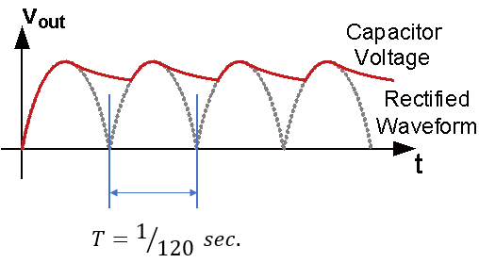  
This is still not a good voltage as it now swings from 17V of the peak when the capacitor is fully charged to the lowest point where it is the most discharged. The higher the capacitance of the capacitor the smaller the range is, the range is also called a **ripple**. If a capacitor that is too small is picked then the ripple may be too big to the point of not making enough power to stay above 0V.

Ideally we want to keep the ripple as small as possible, but I am not made of money and big capacitors are expensive. What we will do is add multiple smaller capacitors to gain more capacitance cheaply. The smaller capacitors also have a faster response to voltage changes (lower inductance).  
  
We add these capacitors to both the +12V and -12V. Here is how it looks like:  
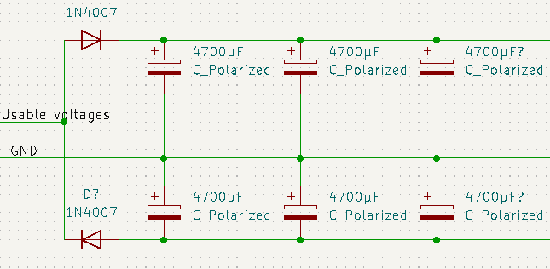

As you can see 3 capacitors were picked. This is because I saw a video of a guy making one and it seemed like he got good results. Might be overkill, but the response time is very good I imagine.

To pick capacitors using math you can use this formula:

C (Farads) = (max amps passing through rail)/(mains frequency * desired ripple)

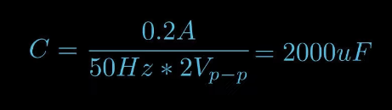

Ex: C = 0.5/(50 * 2) = 0.005 F = 5000 μF

So using the example we need a 5000μF capacitor to meet our need of a ripple that is 2 V. The ripple means that the voltage fluctuates between 17V and 15V

This is still not a good enough voltage; it is not even 12V. For the final step we need to use a linear regulator that will take the messy signal from 17V to 15V and output a smooth 12V and discard the extra voltage as heat in their heatsinks. 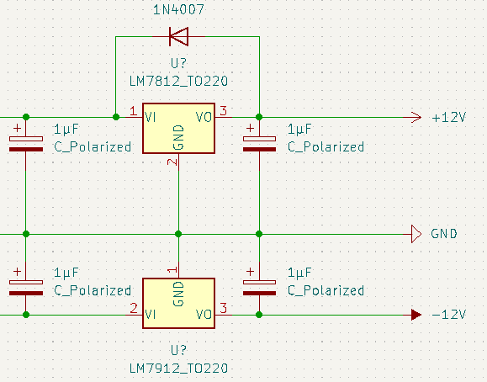

The linear regulators are different depending on what voltage they handle: LM78 type for positive, LM79 type for negative. Extra capacitors that are small are added before and after the regulators to handle very quick voltage spikes. The LM78 cannot have positive voltage going into the output of it which will definitely happen if the capacitor is right next to it, that is why a diode is added to let the power back to the input side on circuit shutdown.  
  
Now we have stable +12V, -12V and GND.

MIDI to CV converter

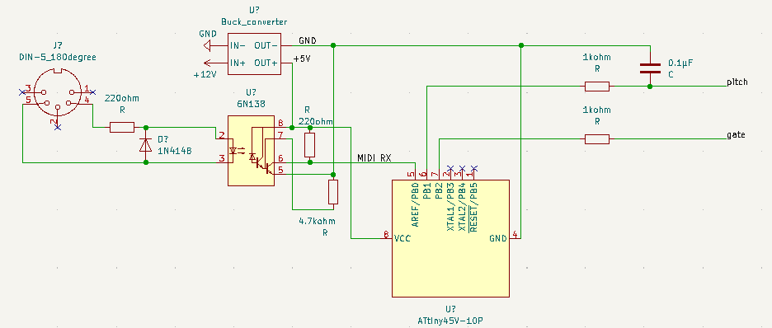

This midi to CV setup is based on the “DIY Good Ol’ MIDI to CV” guide.

The midi is needed to connect a keyboard to the synthesizer, the keyboard controls what is being played. Midi uses a DIN-5 180-degree connector (it is not only used for midi) to transport UART data at a baud rate of 31250 which needs to be turned into voltage that can be played back.   
  
To convert we will need a microcontroller to transform the UART data into a voltage of pitch and some other data and we are going to need a octocupler to get the data from MIDI without actually connecting to the midi cable outputs.

Midi comes in using two connections, one carries the UART and the other kind of acts like a ground. The resistor is there to limit the current going into the octocupler LED that is inside it. The diode is to protect the LED from reverse voltage. You can see the LED picture on the inside of the octocupler.  


The octocupler then reads the light signals form the LED using a photoresistor. The transistors inside it are to get a more reliable signal, they are supported by a pull-down resistor outside the chip. The actual output of the chip has a pull-up resistor on to help with stability. The power to this circuit is provided using a buck converter which efficiently steps down 12V to 5V.



Now we have a clean UART signal but it is not a analog signal that other analog electronics can understand. For that a microcontroller needs to be brought in, to translate it.

The microcontroller takes in the UART and outputs pitch and gate. The pitch is a PWM is a signal which is passed trough a capacitor to smooth it out and turn it into a analog signal. The Gate is just a on or off signal. Both of these signals are current limited using a 1K ohm resistor.



Now we have a pitch and gate signal that we can plug into oscillators.

Voltage controlled oscillators (VCO)

The pitch signal that we have must alone is just a control signal, if you play that on a speaker trough an AUX cord it will not do anything as it does not have a frequency, it at most changes’ voltage up and down. To get sound a voltage needs to have a frequency. A voltage that swings up and down at a frequency of 20 Hz to 20kHz can actually be heard from a speaker. This is what VCOs can help with.

VCOs generate signals like saw tooth, square and triangle waves. They oscillate at frequencies mentioned before and they make different sounds even when oscillating at a different frequency as the other wave types.

How the waves look like bellow. Ignore the voltage range the of 0 to 1 V, the more voltage range the wave has the louder it is .

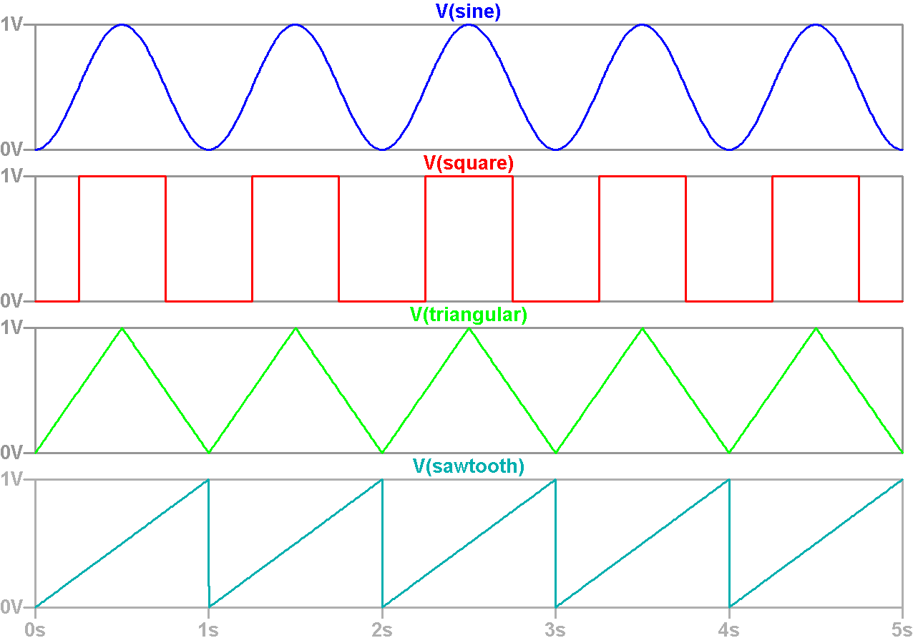

# Part 1 of making a VCO. Creating a sawtooth wave

A Schmitt trigger, resistor, diode, and a capacitor can be used to generate a repeating sawtooth wave.

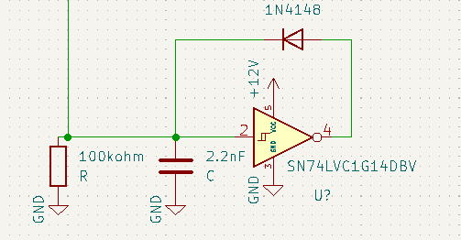

The most important piece is the Schmitt trigger ST. It is a logic gate that **watches** an input voltage and depending on if the voltage is rising or falling outputs a reference voltage max or reference voltage min. The Schmitt trigger reacts to the falling or rising only if the voltage passes a certain threshold. The output voltage is opposite of the state, falling – max, rising – min. The reference voltages for our ST will be min 0V and max 12V.

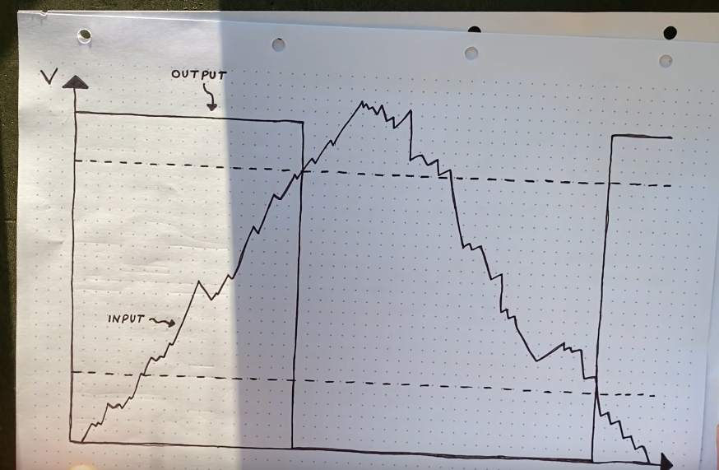

When the circuit is started up the capacitor is not charged so the input to the ST is 0V, this means that with our reference voltage the ST will output 12V.

The output of the ST passes trough a diode to prevent any voltage flowing to the output of the ST. From the diode the voltage heads towards a capacitor and a resistor. The voltage does not want to go to the resistor and instead flows to the capacitor. As the capacitor charges up the voltage of the on the ST input starts rising as well until it passes the threshold for the rising voltage in the SC, which flips the output of the ST to 0V. The circuit with the capacitor and resistor slowly discharges though the resistor as there is no other way for the current to do. This goes on until the capacitor discharges the voltage past the min threshold and the whole thing repeats again. The voltage graph looks exactly like a sawtooth wave at some frequency.

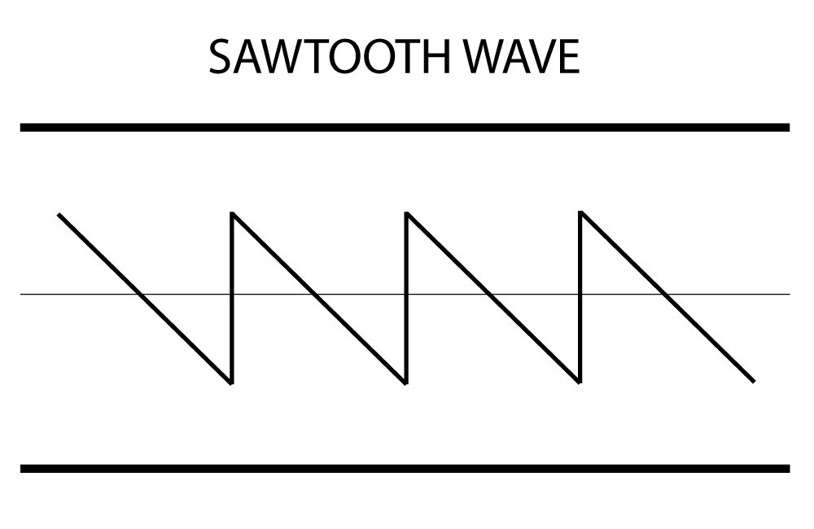

The frequency of the sawtooth depends on the capacitor and the resistor sizes. The capacitor size determines for how long the sawtooth downward phase is, the bigger the capacitor the longer it is. If the capacitor is too big the initial spike of the sawtooth will be more curved, that is not a good thing. The resistor determines how fast the circuit discharges as well, the bigger the resistor the slower it discharges

When working with a ST chip it is important to ground all unused STs, for signal stability. To measure this circuit connect a positive lead to the intersection point next to the cap and a negative one to ground.   
  
We got a sawtooth now, but if we try to hook it up to a speaker, the saw tooth will disappear because it will find a place where to dissipate the voltage, the capacitor never charges. So, if we interact with the wave, it is destroyed.

To fix this we can use a operational amplifier (op-amp) buffer. The op-amp can be used to sort of copy a signal without letting it go trough the op-amp. The output of the op-amp in this case is the exact same wave but with more power, it does not go away when you hook it up to something. The op-amp also uses a max an min voltage reference, but this time instead of ground it has -12V. The negative voltage reference gives more room for the op-amp to accurately copy a voltage in this case.

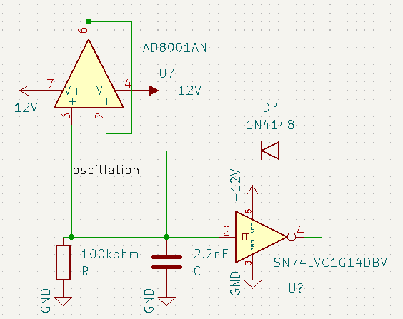

Ok, now we have the waveform and we can hook it up to things without destroying it. However, if we hook it up to our speaker now it will destroy it as the voltages are too high. The voltage is also not cantered around ground but instead is entirely on the positive voltage range. Speakers use negative voltages as well for audio playback.

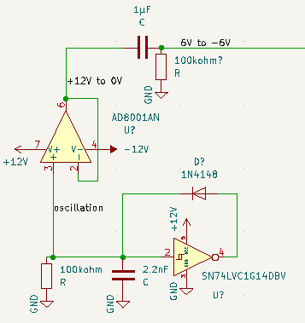

We can first solve the cantering issue using AC coupling. AC coupling removes the DC part or unchanging part of the signal and centres the signal around ground. Only the changes in voltage are passed through.

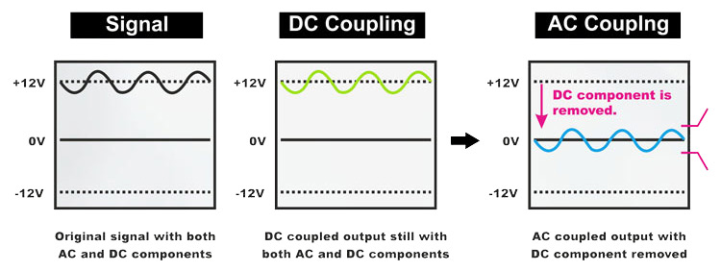

Creating ac coupling is very simple, you connect a non-polarized capacitor to the output of the op-amp and a resistor. The capacitor lets only the changes in voltage pass trough and the resistor grounds the signal so it doesn’t float around and only hovers around the ground.

Now we have a voltage that is cantered on ground, it has both positive and negative voltage as is required by speakers.

The voltage is still too high though. Some voltage divider resistors can be used to fix this.

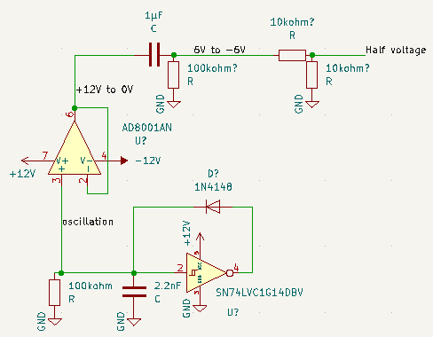

This is just a standard volage divider circuit. The formula is V = R1/(R1+R2) * voltage. It is important to measure the output voltage of this circuit in real life before connecting it to a speaker. The based on the schematic the voltage at the end should be +3V to -3V, that is still too high of a voltage. Headphones and speakers can interpret voltage levels that are from +- 0.1V to +-1.5V or +-2.0V. Adjust the voltage using different resistors. Now we can play back what he sawtooth the VCO using speakers, please don’t use headphones yet as hearing damage can happen if something is configured wrong.

Now we have sound coming trough speakers. The sound is probably high pitched and it does not change. It is not a VCO yet as it does not have any control.

# PART 2 adding voltage control

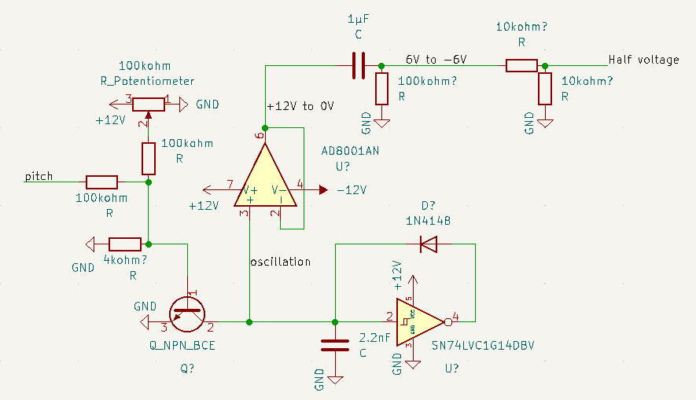

To control the frequency of the sawtooth wave as said earlier we can swap the capacitor and resistor. Changing the capacitor by hand is inconvenient, a better way would be to change the resistor. You might think to go with a potentiometer, but that is not going to make the resistor voltage controlled. Generating pitches manually by hand would be very useless.

To control the resistance using voltage a NPN transistor can be used, not using its normal operation of switching, but its lower voltage region, before it goes into normal functionality. This region can control how much current the transistor can pass through using a specific voltage, acting exactly like a resistor.

The image bellow shows what current you can get using voltages before the 0.7V normal operating range. It is exponential. The less current the bigger the resistance effectively.

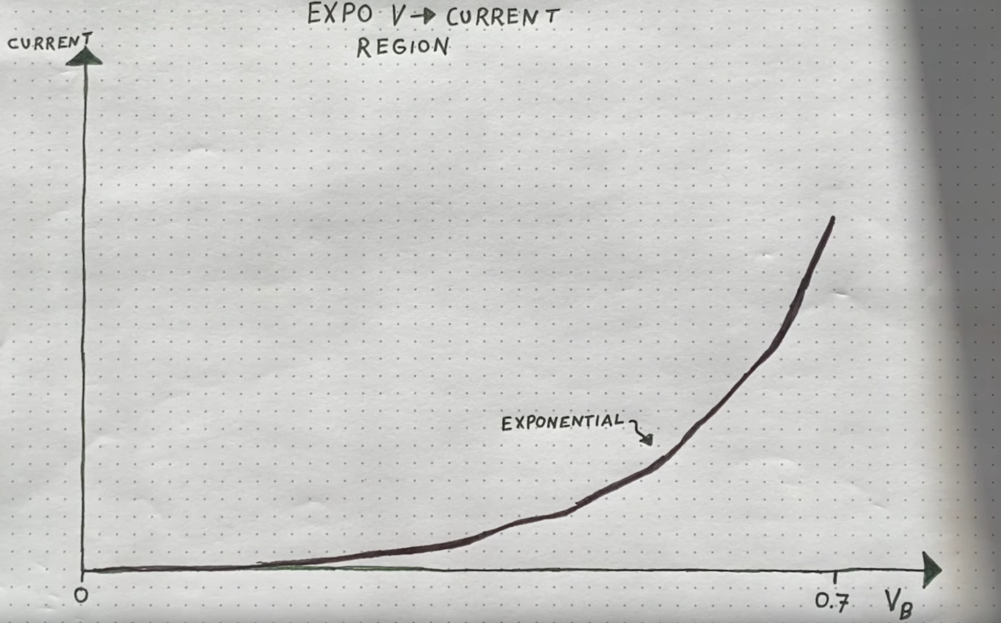

This is also very similar to how sound is represented; it is also an exponential curve. So this is a perfect use for the transistor.

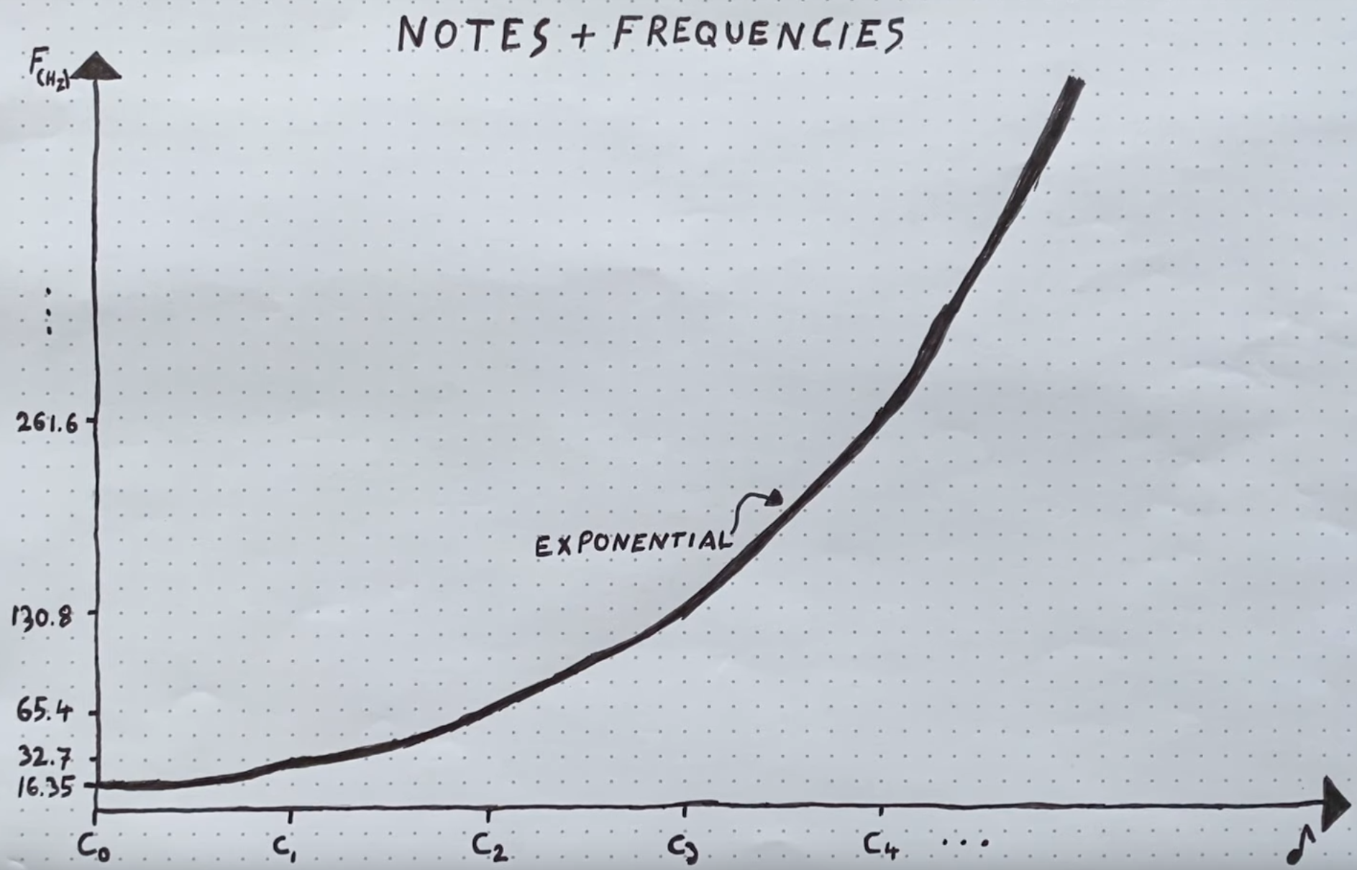

For voltage control we can bring in the pitch that we got from the midi to CV converter. On the schematic there is a lot of stuff going on, but please focus on the pitch wires and the transistor for now.  
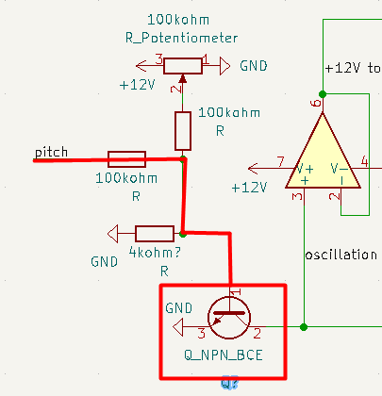  
We replace the 100Kohm resistor to ground we had with the NPN transistor which leads to the ground. We also attach the pitch pin to the transistors base, but first we limit the current of the pitch pin using a resistor, the transistor can’t handle much. Now we have the pitch going into the transistor, but the voltages from the pitch are too high, one octave is one 1V. This is way above the region of 0.7V we are targeting. If we let this be applied to the transistor it will just let all the current go through with very little resistance. We need to scale down the voltage.

For this we can add a resistor to ground after the 100kohm resistor already placed on the pitch pin. This is the formula for getting the voltage out when we have decided on resistors.

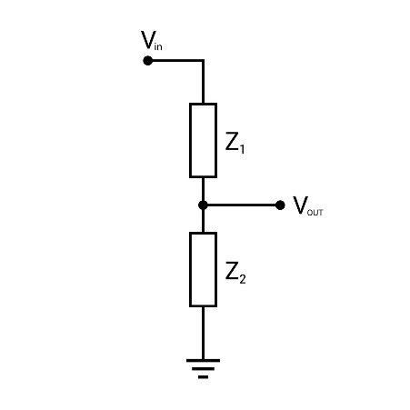

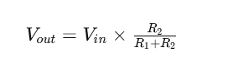

We want to maybe have the voltage very low so that 8V or something is 25 times smaller. We can use this formula instead, to find the resistor we need.

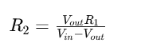

Plug everything in: **((8/25) * 100000)/(8-(8/25)) = 4166.66667** (let’s just say it is 4K resistor)

So we add the 4K resistor that leads to ground after the 100kohm one.

Now we have pitch signal that is from 0V to around 0.3V. If we apply that to the transistor, we are going to get a sound that is very low in frequency and not the sounds that we have in the pitch. What we need now is to offset the signal to a voltage that can be considered in line with what the pitch represents, like tunning a guitar, we need to raise the tension. We can do that by adding another constant voltage on top of the shrunken pitch signal.

We cant really get a voltage that is exactly 0.4V or some exact amount that would fix our tuning out of nowhere, we have to make it. We will use a potentiometer as a voltage converter for this.

A potentiometer can be used as a varying resistor or a voltage divider, it has parts contained for both in one package. If we supply the potentiometer with 12V from our power supply, connect it to ground and use the output pin we get a voltage divider.  
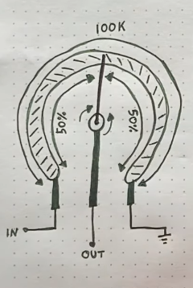

The center position divides the voltage by two as on 50kohm resistors surround the output pin. We also do not want this to put out much current so we attach a 100kohm resistor to the output to limit the current. The voltage of this will also have to be scaled as the output is still too high, we put this before the 4k ohm voltage divider.

To add the voltages together we use a passive mixing circuit. This type of circuit is very simple and uses only resistors to combine the voltages. The output is a weighted average of the voltages. The resistors should be equal otherwise the calculations is a bit different.

Calculating the output voltage if the resistors are equal:

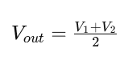

If they are not equal:

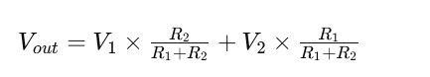

We are not going to calculate this now as the voltages vary between 0V to 12V on the potentiometer and 0V to 8V on the pitch pin. We would need to calculate on these values. We do know what our resistors are already there on the circuit and that they are equal – 100kohm.

Now we have the complete circuit. You will need to use the potentiometer to calibrate it to be in the correct frequency range. This circuit has problems though, it is susceptible to temperature changes in the transistor which makes the resistance be lower. It is also probably not going to calibrate that well, the pitch between octaves will not match, so C1 and then C2 will be C1 and A2.

# Part 3 fixing temperature issue and making calibration easier

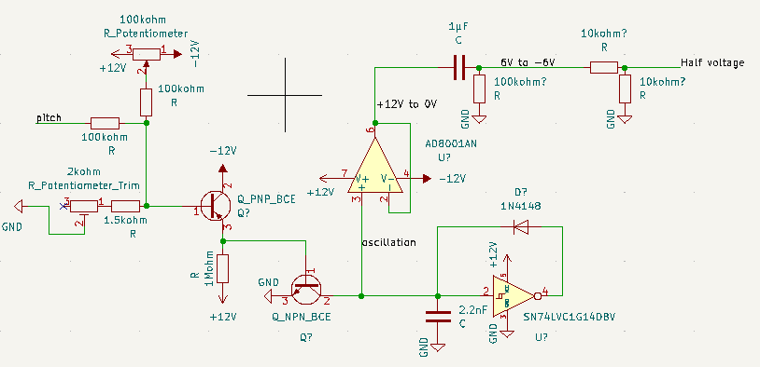

First, we need to fix the temperature issue. To do that we need to introduce the opposite of a NPN transistor, a PNP transistor.

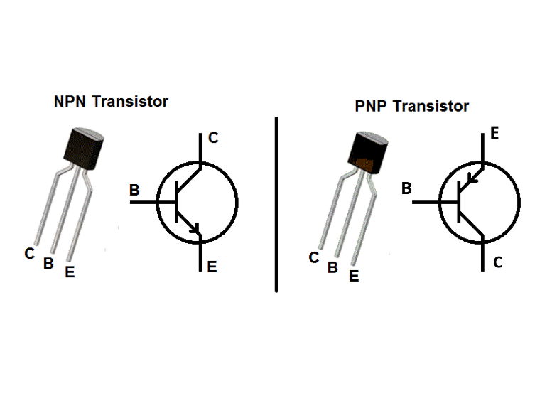

The inverse of the NPN transistor. The PNP transistor uses voltage to keep the current from flowing through the transistor, the more voltage on the base of it the less current flows through to the collector. On this type of transistor, the current flows from the emitter to the collector. It does have an inherent energy that wants to close the emitter to collector flow.

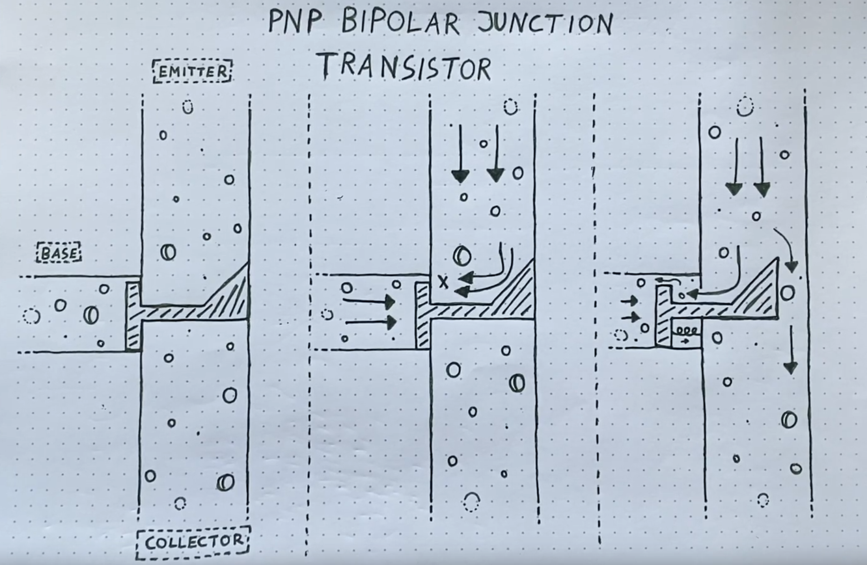

It is often setup in an ‘emitter follower’ circuit, it is used to copy voltage of the base to the emitter side. For this circuit the energy inside the PNP transistor is really important as the decreasing the current flow a bit boosts the copied voltage by 0.5V. This is a problem that need to be solved.  
  
Circuit of the emitter follower:

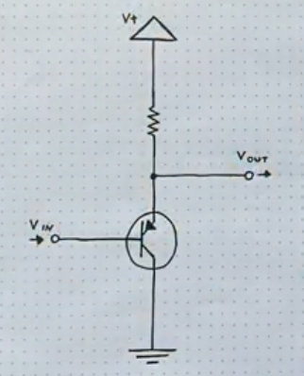

The emitter follower circuit is very similar to the voltage divider circuit. The PNP transistor acts like a R2 resistor with a resistance set by Vin.

This type of transistor also has the problem of its current flow changing based on temperature, it opens up more. In the emitter follower circuit, it would mean that less of the voltage is copied. This is good to balance the NPN transistor.

For this circuit the energy inside the PNP transistor is really important as the decreasing the current flow a bit boosts the copied voltage by 0.5V. This is significant for what we plan to do with the circuit, we are going to connect the Vout to the NPN transistor. It means that the volage that is used to supply the NPN transistor is no longer 0.5V but 1V, this makes the NPN transistor act in the linear region, this breaks the functionality of our circuit. To fix this we could remove the potentiometer offset and supply a raw scaled pitch signal with no offset added, but then the lowest volage offset would still be 0.5V. This would not be good, we need to be at a lower voltage state than 0V to so when the voltage is added it is still in a good range of 0V to 0.7V. Luckily we have a -12V rail. Instead of having the potentiometer at 12V to 0V we can change it to 12V to -12V, when the voltages are added together in the passive mixer they will be subtracted if the one of the voltages is lower than 0V. This offsets our signal down in voltage, but the PNP transistor will not be able to handle this as its lowest voltage is 0V, we can change this also, make the circuit from 12V to -12V. There shouldn’t be problems as this circuit just copies the voltage.

For the resistor choice in the emitter follower circuit, we have to consider how much current we need to flow out the Vout. Down the line is a NPN transistor that really does not want much current at all, that means we can go big with the resistor 1Mohm and it should not cause problems.

Now we have solved the problem of the temperature change, it should not be a problem now.

To solve the tuning issue, we can add one more adjustment, that will make things more precise. We can add a trim potentiometer to the voltage divider circuit we have in series to the existing resistor and its resistance divided by two. This trim potentiometer needs more turns to change the resistance, this gives more precision. So to tune the the VCO we will now first twist the offset potentiometer and then we will twist the voltage divider trim pot for precision.

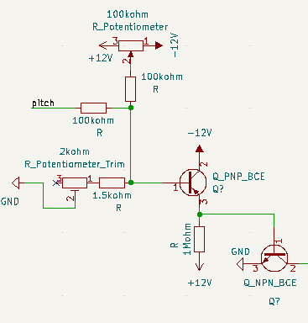

We now have working VCO that can be used.

# Part 4 Improving PNP transistor temperature offset even more.

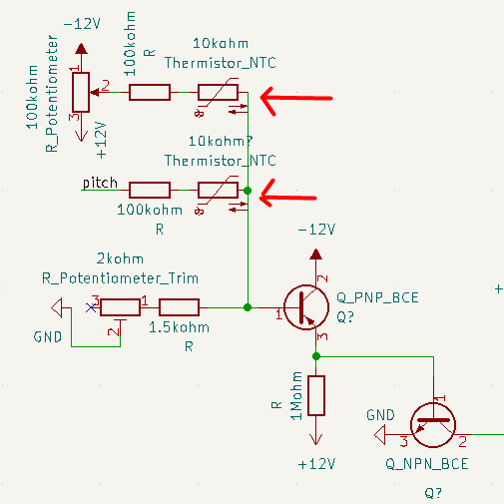

The temperature response is still stronger on the PNP transistor than the NPN one so we need decrease the voltage a bit automatically depending on the temperature. We can accomplish this by adding 10kohm thermistors in series with the resistors already on the pitch and offset inputs. In effect this will decrease the more because the 100kohm resistor and the thermistor resistances will add up and be used in the voltage divider calculation later. 10kohm thermistors were picked because Rene Scmittz also picked them.

# Part 5 Making the tunning process even more precise.

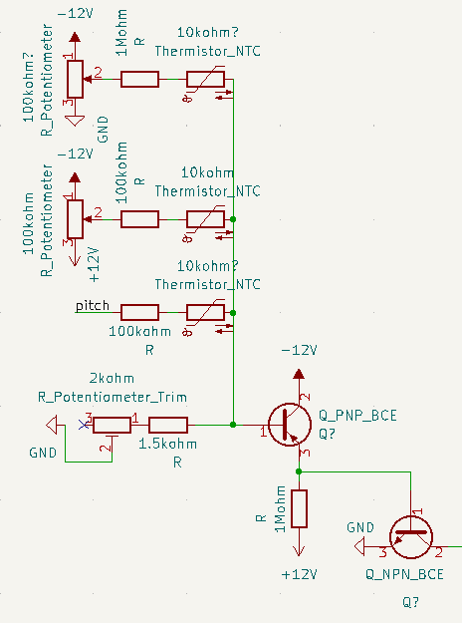

The offset potentiometer tunning is still too difficult and imprecise. We can fix this by adding another potentiometer that offsets the signal but at more precise level.

We copy the offset input configuration and change the 100kohm resistor to be 1Mohm instead as we want a very small adjustment to be possible (the volage divider will use this resistor and the passive mixer will work fine with this change). We also change the potentiometer inputs to be not from 12V to -12V but from 0V to -12V. This means that we will get negative voltages from this input. It can also be to positive 12V but we will try this configuration.

Now the VCO is completely finished and will work very well in the 0 to 5 octave range

# Part 6 Adding more features – square wave

To create a square wave we can use the sawtooth wave that we already have and pass it thought the Schmitt trigger (ST) again. The sawtooth rise will trigger a immediate low signal from the ST that will last until the sawtooth voltage goes bellow the lower threshold, then it will be high.

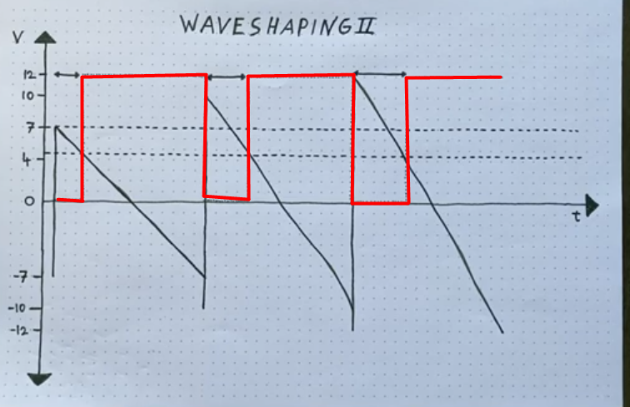

We can control the amount of high and low signal or duty cycle by offsetting the sawtooth wave up or down in voltage as that will make voltages stay above or below thresholds for longer or shorter in that way varying the duty cycle. To offset the sawtooth wave before we plug it into the ST we need to use an op-amp. Look at the description section for the op-amp component.

We will use the op-amp with its output connected to its – input but we will add a voltage divider circuit. For R2 of the voltage divider we will put a potentiometer in a varying voltage configuration. For the R1 we have to choose a big enough voltage so the signal has enough resolution, bigger resistor = more resolution. Go with 200kohm. Now we are able to control how much is the signal is amplified.

Before we plug the amplified sawtooth into the ST we need to choose where to sample the sawtooth, we have the 12V to 0V sawtooth coming out of the earlier op-amp buffer that copies the voltage from the sawtooth oscillator circuit. This sawtooth cannot be amplified much as its peak is already at 12V. We will instead choose the AC coupled sawtooth wave as it is hovering around 0V. That will give us space to work with if we want a very low duty cycle with the wave barely reaching, he upper threshold of the ST or very high duty cycle with the sawtooth raised way up in voltage.

There is one more thing we need to take care of before we plug this into the ST, our ST is connected to 12V and 0V, if we plug a signal hat is bellow 0V in it will cook the chip. We need to remove the negative volage, the threshold is above 0V anyway so nothing of value is lost.

To fix this we just block out the negative voltage using a diode that lets the positive voltage pass. The problem is that if the voltage is negative at a moment, there will be no voltage flow on the other side, that means the wire will be floating and picking up static voltage, for this we add a pull-down resistor of 100kohm.

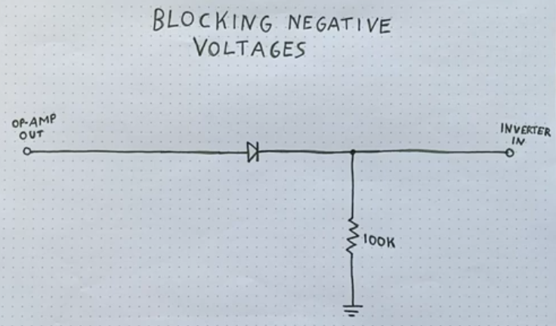

Now the signal can go into the Schmitt trigger. Bellow is how the output would look on an analog oscilloscope:

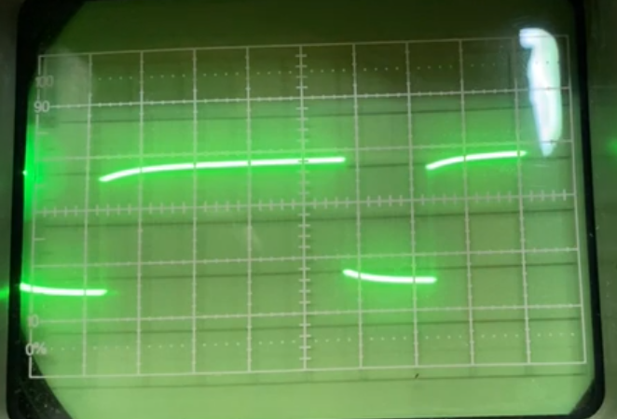

Now we have a signal that is 12V to 0V we need to scale it again to be centered around 0V. I think we can do this without the op-amp for now, to deviate from how we handled the sawtooth wave. We add AC coupling to solve this.

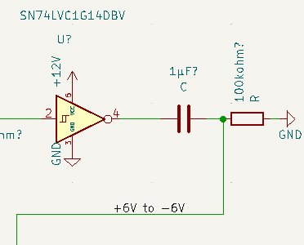

Now we have a voltage from +6V to -6V, we need to match it with the standard voltages used in modular synth outputs which is 10V to -10V. To do that we will again use an op-amp with a scaling factor of * (10/6). For this we use a voltage divider circuit with R1 as 300kohm and R2 as 200kohm

Common components explanations:

# NPN transistor

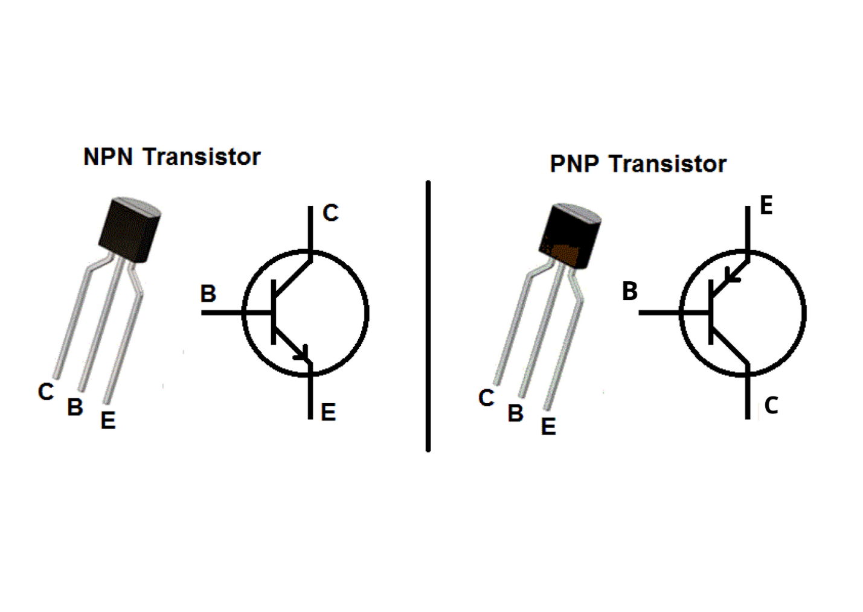

Uses a high input to open the flow of current trough it. Works like a switch in normal operation when the base is above 0.7V. Can be used as a variable resistor when the voltage is bellow 0.7V. The lower the voltage on the base the higher the resistance.

It has 3 pins:  
Collector – Is the input, the voltage that we want to control if it passes or not

Base - The switch to let the voltage flow or not

Emitter – The output of the voltage if the switch lets it go through.

In the bellow diagram, the flow of the base does not actually go out using the emitter.

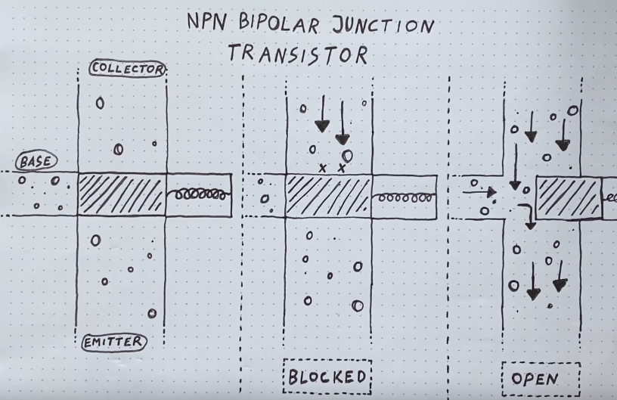

When the voltage is bellow 0.7 this is how the current looks like:



This transistor has a problem though, if the temperature rises it lets more current trough. It needs to be balanced.

# PNP transistor



The inverse of the NPN transistor. The PNP transistor uses voltage to keep the current from flowing through the transistor, the more voltage on the base of it the less current flows through to the collector. On this type of transistor, the current flows from the emitter to the collector. It does have an inherent energy that wants to close the emitter to collector flow.



It is often setup in an ‘emitter follower’ circuit, it is used to copy voltage of the base to the emitter side. For this circuit the energy inside is really important as the transistor decreasing the current flow a bit on its own increases the copied voltage by 0.5V.  
  
Circuit of the emitter follower:



The emitter follower circuit is very similar to the voltage divider circuit. The PNP transistor acts like a R2 resistor with a resistance set by Vin.

This type of transistor also has the problem of its current flow changing based on temperature, it opens up more. In the emitter follower circuit, it would mean that less of the voltage is copied. This is good to balance the NPN transistor.

In the emitter follower circuit that is counteracting NPN transistor temperature problems, the rise in voltage out by 0.5 is significant. It means that the volage that is used to supply the NPN transistor is no longer 0.5V but 1V, this makes the NPN transistor acts in the linear region, this breaks the functionality of our circuit. To fix this we could supply a raw scaled pitch signal with no offset added but then the lowest volage offset would still be 0.5V. This would not be good, we need to be at a lower voltage state than 0V to counter act this, luckily we have a -12V rail. Instead of having the potentiometer be from 12V to ground we can make it be from 12V to -12V, when he voltages are added together in he passive mixer they will be subtracted if he voltage is lower than zero. This offsets our signal down in voltage, but the PNP transistor will not be able to handle this as its lowest voltage is 0V, we can change this ground to -12V also, there shouldn’t be problems as this circuit just copies the voltage.

For the resistor choice in the emitter follower circuit we have to consider how much current we need to flow out the Vout. Down the line is a NPN transistor that really does not want much current at all, that means we can go big with the resistor 1Mohm.

# Potentiometer



A potentiometer can be used as a voltage divider or an adjustment for how much resistance a resistor should have. They resistance value on marked on them is the max possible resistance.

In – connected to 5V or something

Out – connected to other components

Ground – is not connected

Result – the potentiometer is a variable resistor

In – connected to 5V or something

Out – connected to other components

Ground – is connected to ground

Result – the potentiometer acts like a voltage divider.

# Operational amplifier

Can work as a buffer or a voltage amplifier.

Volage buffer circuit:  
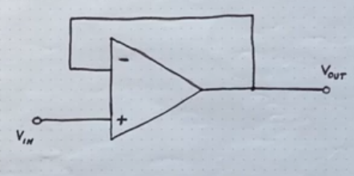

The – and + are both inputs. The output of the op-amp is not the signals that are on its inputs a voltage derived from the power supply connected to the op-amp

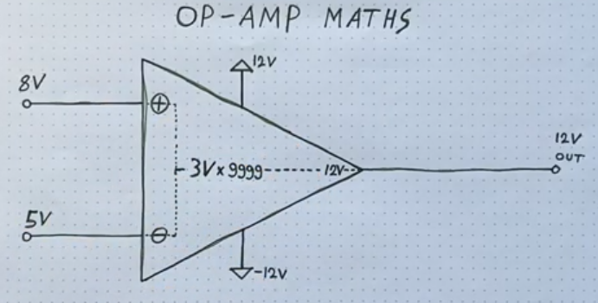

The op amp amplifies the difference between the inputs (+8V – 5V = 3) by a very large number, maybe 100 000. If the number is above its voltage range (+12V to -12V) then it uses a 12V output. If the number is lower than its range it uses -12V as output.

In a buffer configuration. If the voltage starts at 0V in the initial state of the op-amp output the calculated voltage will be very high, the op-amp will want to put out that voltage but the voltage will rise slowly and it will read the slow voltage rise as an input. As the voltage rises on the op-amps output the difference between the two inputs decreases very quickly until it gets to the point that the difference is so small that the gain cannot put out a massive voltage. It kind of acts a capacitor that lets out a bit of voltage at a time and not an instant voltage signal, or a water bucket that keeps topping up another bucket if it sees that it needs more. This means the if the output is routed to the inputs the voltages on all pins of the op amp will match voltage. **The outputs mirror the input. An amplifier that does not amplify (unity gain amplifier).**

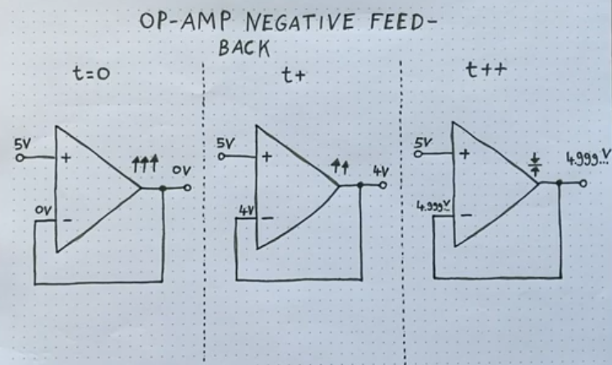

To make this buffer amplify we need to make the output work harder. We can decrease the output voltage before we plug it back to the input, using a voltage converter circuit. If we divide output voltage in half the output will have to double to get the same voltage at the input again.  
